CSIT 432

Fall 2022

Final Project

Mateen Olanrewaju

CSIT 432 Final Project

Fall 2022

**Overview of Virtual Computing Infrastructure**

NS 1

POSTFIX

IMAP

SNORT

**VM 1**

**VM 3**

**VM 2**

NS 2

192.168.1.156

192.168.1.155

10.8.9.88

Internet

10.8.9.89

SQUIRRELMAIL

NFS Client

NFS Server

Apache

Apache

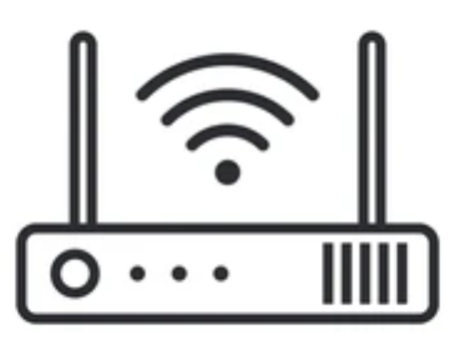

192.168.1.1



10.8.9.1

**VPN**

10.8.9.2 or 10.8.9.3

192.168.1.2 or 192.168.1.3

**GW**

192.168.1.0/24

10.8.9.0/24

Internet

Static Route

Before you get started with the final project do the following:

1. Fill in the IP addresses in the above diagram for your VM1, VM2 and VM3 machines.

There are 6 tasks for the final project. The tasks test your understanding of various labs we have worked on during the semester. A summary of the task is provided below:

|  |  |
| --- | --- |
| **Task** | **Topic** |
| 1 | Routing |
| 2 | Internal Email using Squirrelmail |
| 3 | Internal email from VM3 to another VM3 using the mail command |
| 4 | External Email using Squirrelmail |
| EXTRA CREDIT: | External Email using another mail server |
| 5 | Implementing Deep Packet Inspection Using Snort |
| 6 | Final Report |

**Presentation of your final document counts as 10 points toward the final score.**

**NOTE:** Details for each task and what to submit are provided below. You will be graded on functionality and presentation. Make sure to follow the guidelines and insert screenshots and create tables were required. Instructions on what to submit are provided in each task and the presentation format is provided at the end of each task.

**Task 1: Routing**

|  |  |  |
| --- | --- | --- |
| **Task 1** | **What’s needed?** | **What to Submit?** |
| 1. Ping VM3 10.8.9.xx from your VM1 | **Routes configured from VM1🡪VM2🡪VM3** | 1. Screenshot of ping output on VM1 showing ping reply from your VM3 10.8.9.xxx IP address |

**Task 1**

**Configuration Screenshot with Explanation**

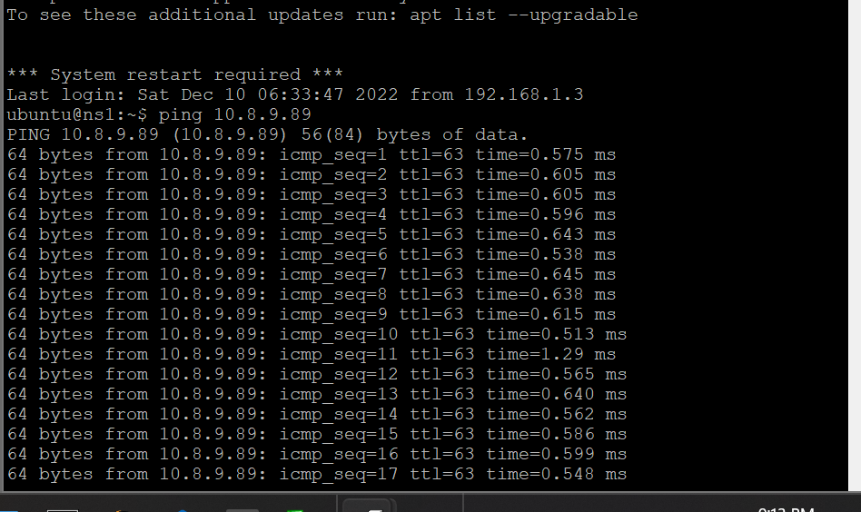

**Table 1:**

|  |  |  |
| --- | --- | --- |
| **Source IP** | **Destination IP** | **Date/Time ping Sent** |
| 192.168.1.155 | 10.8.9.89 | 12/12/2022 / 9:23pm |

**Task 2: Internal email from your Squirrelmail to another user you created**

|  |  |  |
| --- | --- | --- |
| **Task 2** | **What’s needed?** | **What to Submit?** |
| 1. Using Squirrelmail send an email to another user you created on VM3 | **Non ubuntu user account** | 1. Screenshot of Squirrelmail inbox verifying message was received by the other user |

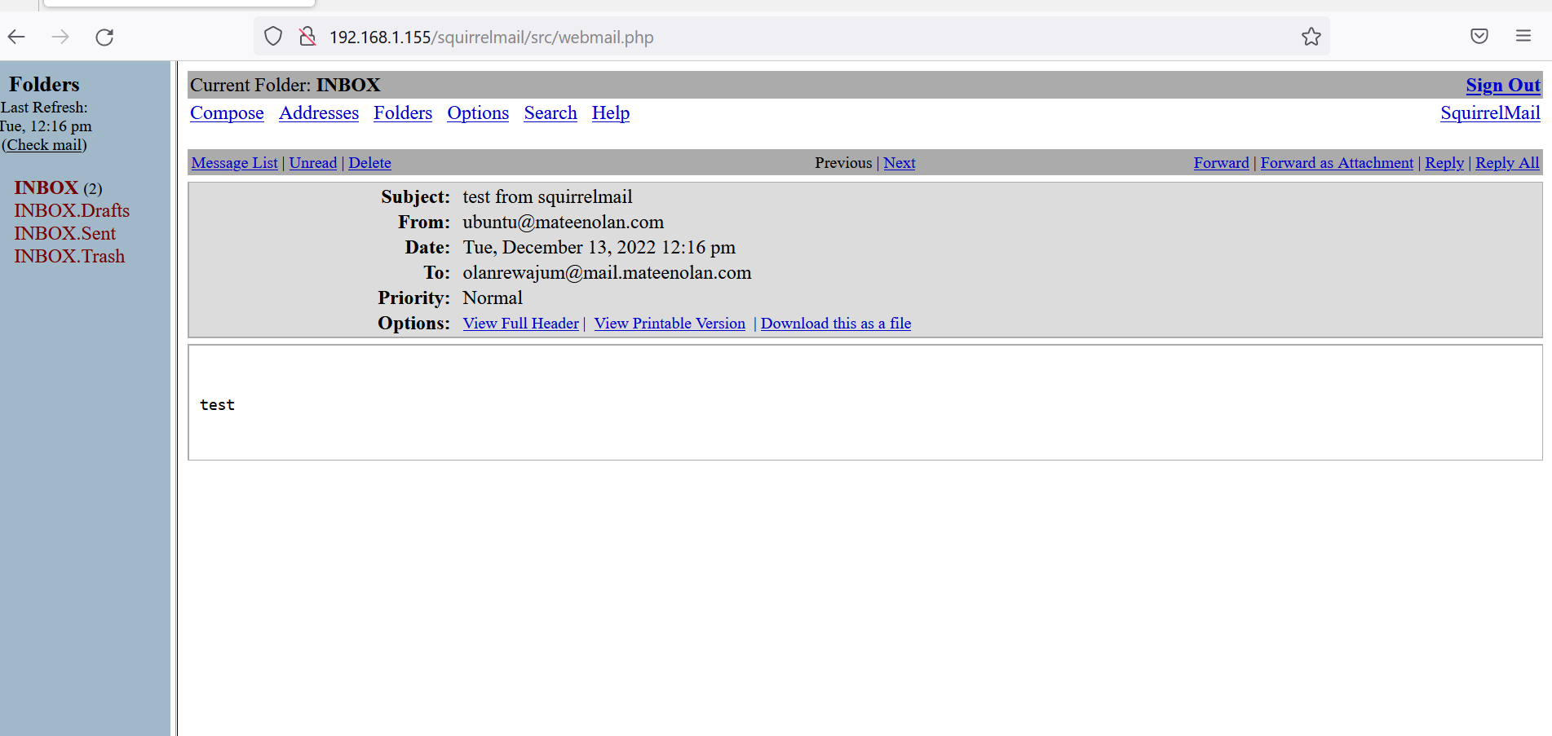

**Table 2:**

|  |  |  |
| --- | --- | --- |
| **Source IP** | **Email address of non ubuntu account** | **Date/Time ping Sent** |
| 192.168.1.155 | olanrewajum@mail.mateenolan.com | 12:16pm |

**Task 3: Internal email from your VM3 using the mail command to leberkc on 10.8.9.81**

|  |  |  |
| --- | --- | --- |
| **Task 3** | **What’s needed?** | **What to Submit?** |
| Send an email **from your VM3** **as the ubuntu user** to the leberkc email account on **10.8.9.81** with domain **mail.greenbergthr1.com**. Make sure to state your name and IP address in the message  **NOTE**: If you have the 10.8.9.81 IP address, then send your message to leberkc on **10.8.9.93** with domain **mail.ranas6.com**  Everyone must send the message to the leberkc account on the 10.8.9.81.  **DO NOT SEND THE EMAIL TO THE UBUNTU USER** | 1. Username for the email address to send the message 2. Destination IP address for the email message | 1. Explain what you did to get this to work. Provide **screenshots** for any configuration changes required with explanations 2. Provide a **table** with the following:    1. IP address you sent the message from (source IP)    2. IP address where you sent the email message to (destination IP)    3. date/time the message was sent |

**Task 3**

**Sender’s Information**

**Configuration Screenshot with Explanation**

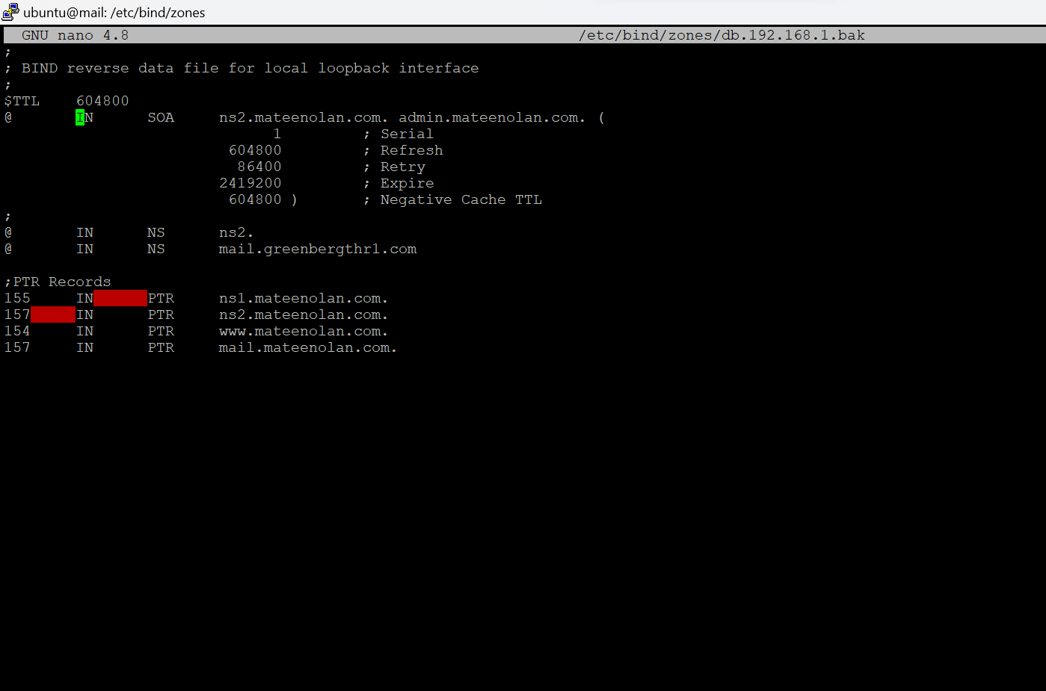

* **So first I logged into the Vm3 and added the mail.greenbergthr1.com into the sudo nano /etc/bind/zones/db.192.168.1.bak directory and saved it.**

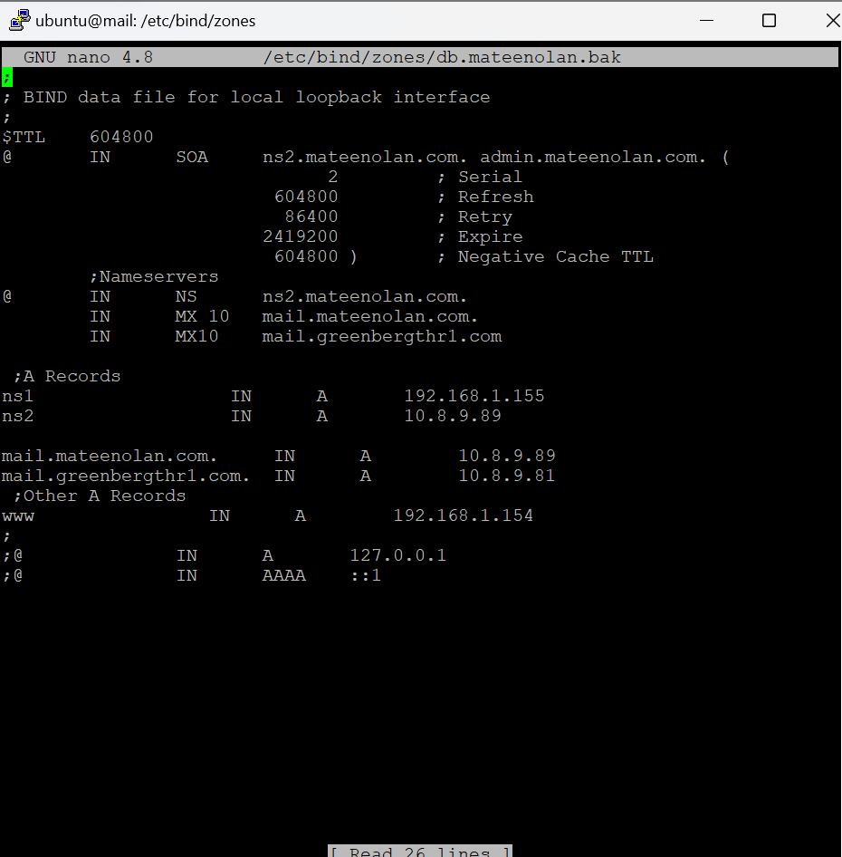

* **Then I went to sudo nano /etc/bind/zones/db.mateenolan.bak to make some changes which I added mail.greenbergthr1.com with the IP address which was 10.8.9.81 into the file directory and saved it.**

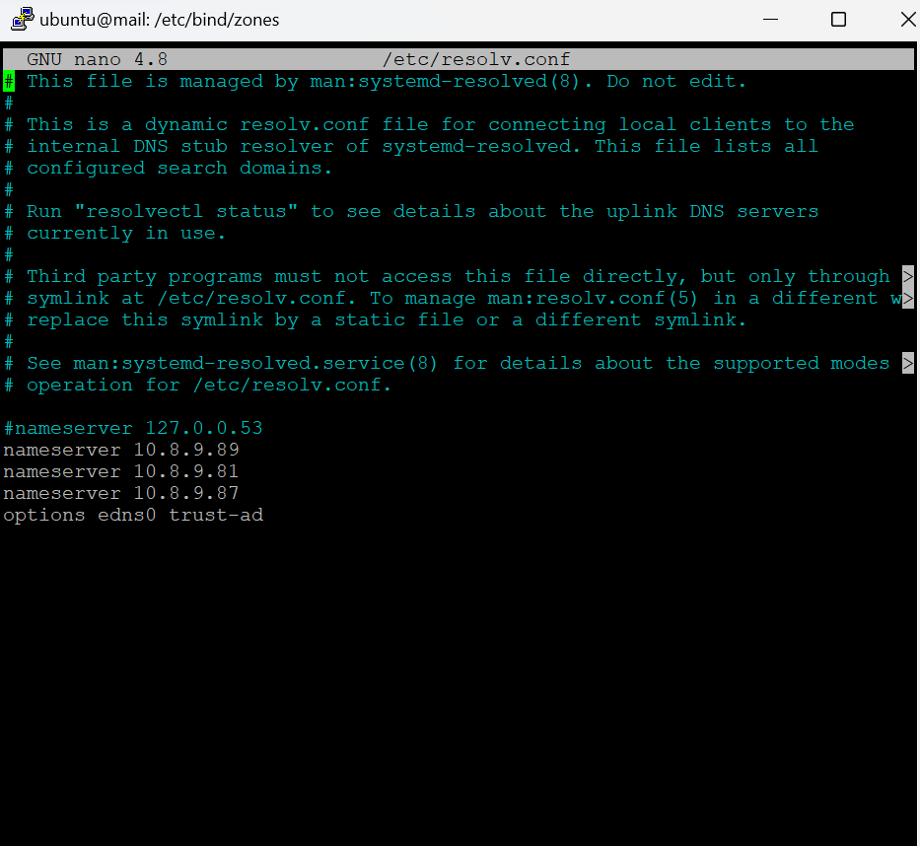

* **Then I went to the sudo nano /etc/resolv.conf file directory and added the nameserver with my Vm3 address. And next I added the 10.8.9.81 address with the nameserver which that is the address of where the mail is going. And the last address is someone else VM3 address in my class which is 10.8.9.87 and saved the file after.**

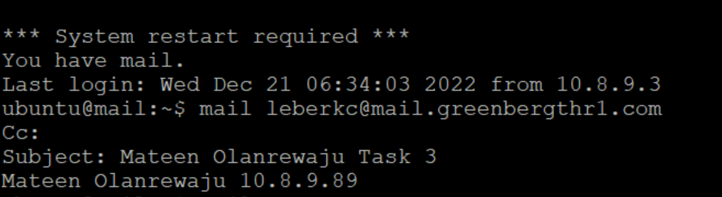

**Table 3:**

|  |  |  |
| --- | --- | --- |
| **Source IP** | **Destination IP** | **Date/Time Message Sent** |
| 10.8.9.89 | 10.8.9.81 | Dec-21/ 16:47:10 |

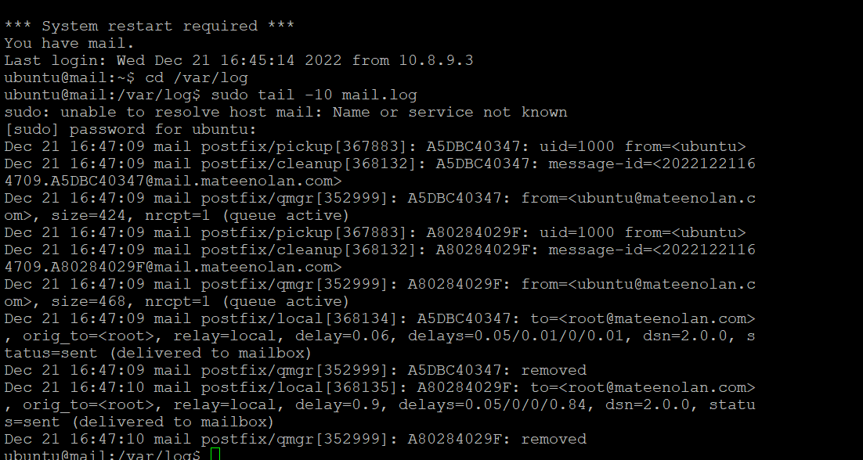

* **Then I checked the status of the mail that I sent using this command:**

cd /var/log

sudo tail -10 mail.log

**Task 4: External email using Squirrelmail**

|  |  |  |
| --- | --- | --- |
| **Task 4** | **What’s needed?** | **What to Submit?** |
| Send an email to an external email account using Sqjuirrelmail on your VM1 web browser. | 1. External email address use your netid@montclair.edu | 1. Explain what you did to get this to work. Provide **screenshots** for any configuration changes required with explanations    1. Open the email message so the contents are visible. and the IP address of your browser should be visible in the screenshot |

**Configuration Screenshot with Explanation**

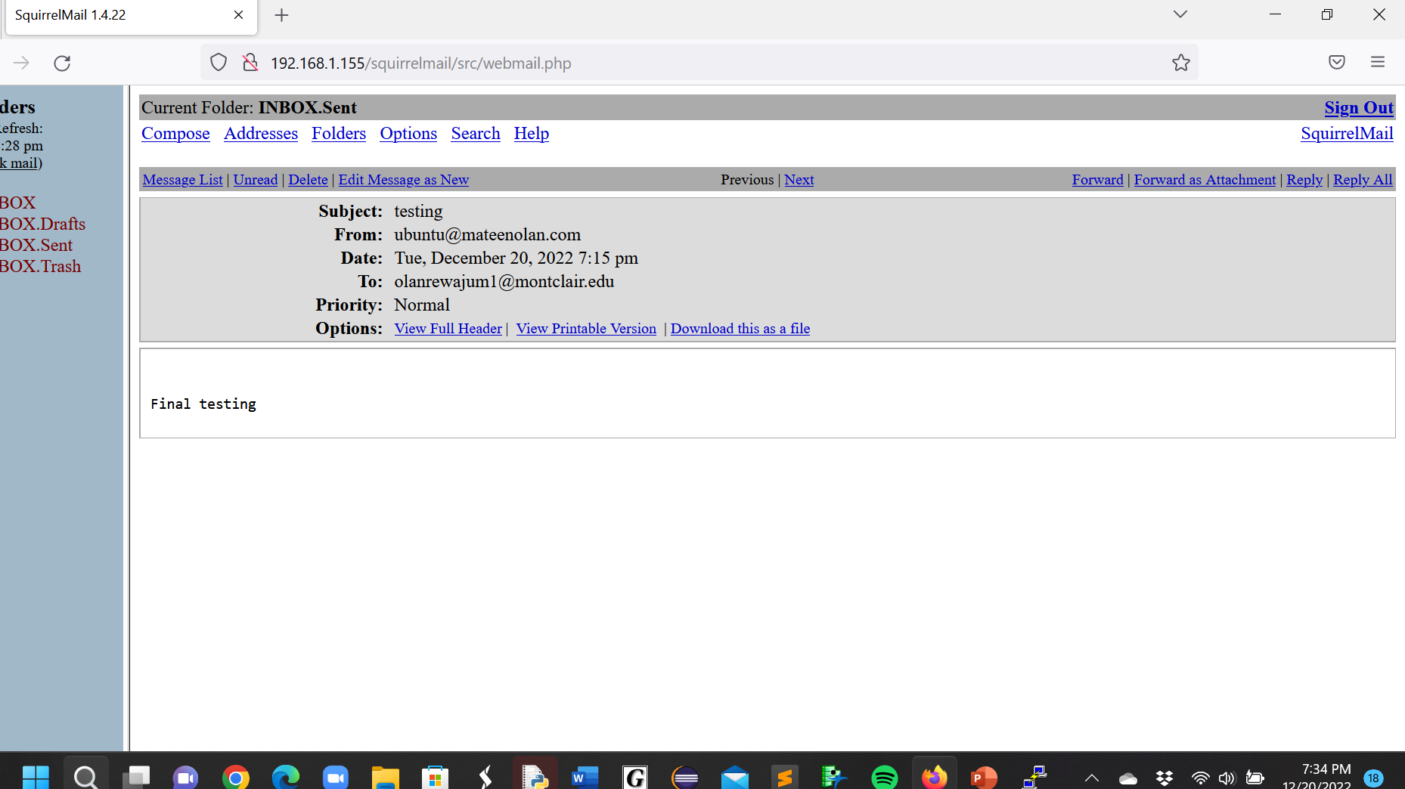

* **Before sending the external email what I did first was I logged into my VM1 which was 192.168.1.155 and then I went into Firefox and logged in as ubuntu user and then sent the email to my school email and then I received a notification in my school email that an email was sent from my ubuntu user which was the screenshot at the bottom. For this to work you must first sign into Putty with your VM1 address.**

**Confirmation of the Email sent to** [**olanrewajum1@montclair.edu**](mailto:olanrewajum1@montclair.edu)**:**

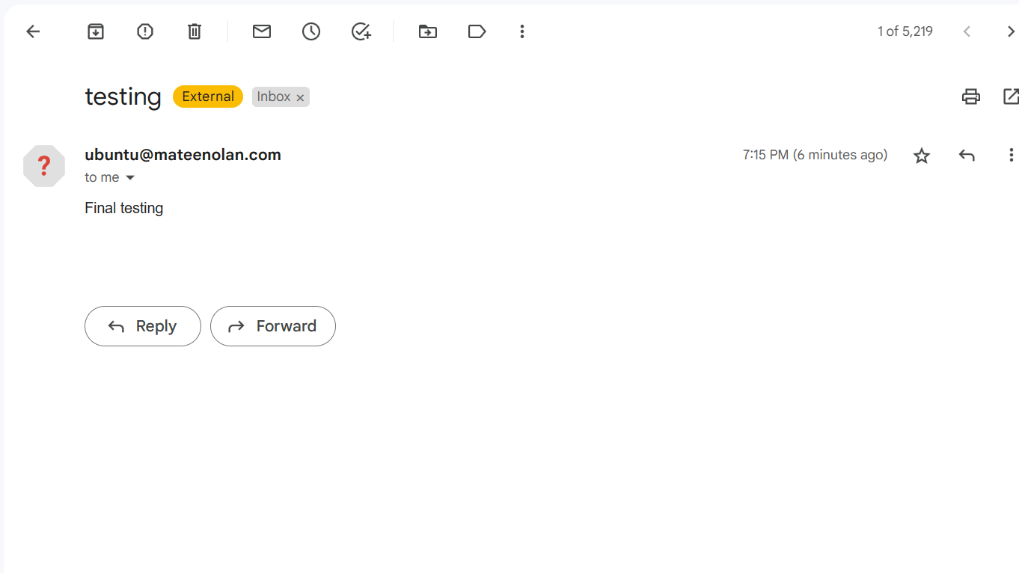

**Table 4:**

|  |  |  |
| --- | --- | --- |
| **Source IP** | **Destination IP** | **Date/Time Message Sent** |
| **192.168.1.155** | **Olanrewajum1@montclai.edu** | **Dec/20/2022 / 7:15pm** |

**Extra Credit (15 points): External email from your Squirrelmail using another mailserver**

|  |  |  |
| --- | --- | --- |
| **Extra Credit** | **What’s needed?** | **What to Submit?** |
| Send an email message to an email address on the Internet from your VM3 **using another student’s mail server.**  **Everyone use the mail server on 10.8.9.81**  **If you have 10.8.9.81 use 10.8.9.93** | 1. IP address of another student’s mail server | 1. Explain what you did to get this to work. Provide **screenshots** for any configuration changes required with explanations 2. Provide screenshot of the inbox with the message and **table** with the following:    1. IP address you sent the message from (source IP)    2. IP address where you sent the email message to (destination IP)    3. date/time the message was sent |

**Configuration Screenshot with Explanation**

**Inbox Screenshot with Received Message. Indicate the IP address of the other student’s mail server**

|  |  |  |
| --- | --- | --- |
| **Source IP** | **Destination IP** | **Date/Time Message Sent** |
|  |  |  |

**Task 5: Snort**

|  |  |  |
| --- | --- | --- |
| **Task 5** | **What’s needed?** | **What to Submit?** |
| Configure rules in Snort to:   1. Detect SMTP, IMAP, HTTP, NFS, and DNS traffic and save the output to a file | Snort installed and configured on VM2. Routes configured from VM1🡪VM2🡪VM3 | 1. Screenshot of your snort rules 2. File that contains captured data 3. Table that identifies:    1. IP address that used SMTP, IMAP, HTTP, NFS, and DNS along with the date and time |